 | Monday | Tuesday | Wednesday | Thursday | Friday
Computers
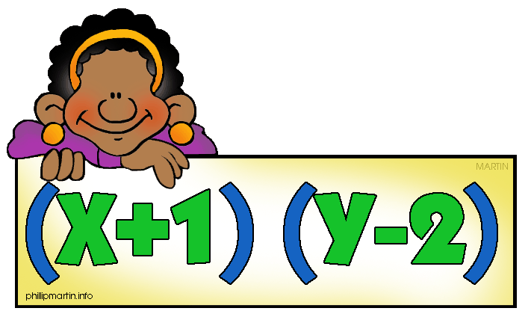
Fact Practice
Games
Writing
Problem Solving
MMeet with a teacher
Work quietly. You will need to check the square once you have rotated through the station. Highlight it if you still need to finish the station. Remember to clean up your materials and stand silently at your station until the teacher tells you to move.

Habit of Mind Goal for the week: _________________________________________
Friday Reflection: One example of how I worked on my habit of mind this week is…

