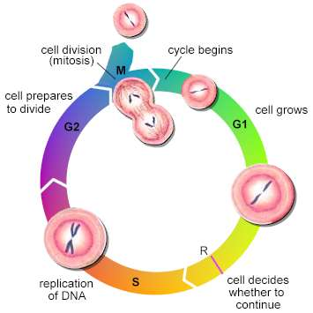
Cell Reproduction Personal Learning Project
Learning Targets:
- I can explain how organisms grow and repair through the cell cycle and mitosis.
- I can describe how the cell cycle is controlled.
- I can explain how organisms produce unique sex cells by the process of meiosis.
- I can compare and contrast mitosis and meiosis.

KEY Pages in the Text
- Chapter 9 pgs. 178-179 & pgs. 184-185
- Chapter 10 pgs. 198 – 200
Step 1: Learning
Video on Cell Reproduction with guiding questions
Due: ___________________________________
Step 2: Practicing
2 options (Choose 1 from below)
- HHMI Biointeractive: The Eukaryotic Cell Cycle and Cancer
OR
- Cell Cycle Regulation POGIL
Due: ___________________________________
Step 3: Demonstrate Understanding
Use the information studied about cell reproduction to develop a personal project that demonstrates your comprehension of the material. The project should directly address and demonstrate your understanding of the learning targets for this unit. Possible formats for the project include:
- Building and explaining a model
- Creating a video or podcast explaining the topic
- Stop-Motion animation video with explanation of the processes
*If you would like to use another format, please see Mrs. K. for approval.
Your project will be presented to a small group of your classmates during class and will count as a test grade on the 3rd quarter grading period. See the grading rubric on the back of this sheet.
Due: ___________________________________

Cell Reproduction Project Grading Rubric
Learning Target | No Mastery | Low Mastery | Approaching Mastery | High Mastery
I can explain how organisms grow and repair through the cell cycle.  ________/25 | I cannot explain the purpose of the cell cycle and mitosis and do not know the vocabulary of these processes. | I can explain the purpose of cell cycle and mitosis but lack in specific details and correct use of vocabulary. | I can explain the details of the cell cycle and mitosis using correct vocabulary. | I explain the details of the cell cycle and mitosis using appropriate vocabulary and place emphasis on the purpose.
I can describe how the cell cycle is controlled.  ________/25 | I cannot explain the how the cell cycle is regulated and do not know the vocabulary involved. | I can explain why the cell cycle is regulated but lack in specific details and correct use of vocabulary. | I can explain the details of cell cycle regulation using correct vocabulary. | I can explain the details of cell cycle regulation using appropriate vocabulary and placing an emphasis on the purpose.
I can explain how organisms produce unique sex cells by the process of meiosis.  _________/25 | I cannot explain how organisms create unique sex cells and do not know the vocabulary of the process. | I can explain the purpose of meiosis but lack in specific details and correct use of vocabulary. | I can explain the details of meiosis using correct vocabulary. | I can explain the details of meiosis using appropriate vocabulary and explain how unique sex cells are formed.
I can compare and contrast mitosis and meiosis.  _________/25 | I cannot compare and contrast mitosis and meiosis. | I can compare mitosis and meiosis but lack in specific details and correct use of vocabulary. | I can compare and contrast mitosis and meiosis using the correct vocabulary. | I can compare and contrast mitosis and meiosis in detail using appropriate vocabulary.
TOTAL SCORE | __________ points out of 100 points possible  Teacher Comments:

